Start points for guided walks and navigation courses
(Please note: not all start points are listed yet. All will be listed by March 2018)
South West guided walk start points

Coniston Tourist Information Centre
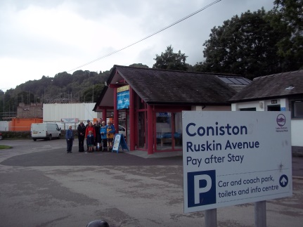 Photo: Lynda Hill
Location: Coniston

The car park is located on the B5285 (Coniston to Hawkshead road) close to the village centre; the B5285 joins the A593 on the east side of the bridge in the centre of the village, close to the Yewdale hotel, Black Bull hotel and the parish church.

Walks – Coppermines Valley and Levers Water, Family Walk – Coppermines Valley, Monk Coniston Tree Walk, Woods, Tarns and Gills, Yew Beauty

Dalegarth Station, Boot
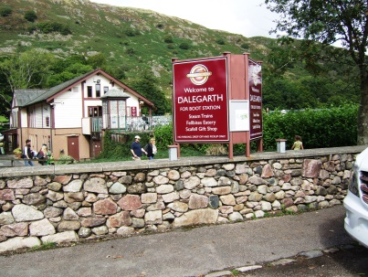 Photo: John Dennis
Location: Boot, Grid ref: NY174007

The station can be reached by train on the Ravenglass & Eskdale Railway from Ravenglass. By road navigate to the Eskdale Valley (several routes) and follow the valley road to Hardknott Pass from the King George Inn at grid reference SD149998.
By Ravenglass & Eskdale railway, take train from Ravenglass (or any intermediate station) and travel to Dalegarth; at Dalegarth leave platform and walk down to station car park.
By road from Eskdale Green, follow the road south east out of the village for about 0.6 ml (1km) to reach the King George Inn (at GR SD 1490 9982). Turn left, signed Hardknott, and follow the main valley road in a general north easterly direction for 1.7 mls (2.75 km) to reach Dalegarth (for Boot) station on the left. Turn into car park.]
Walk – Eskdale Family Wander
Eskdale Green village car park
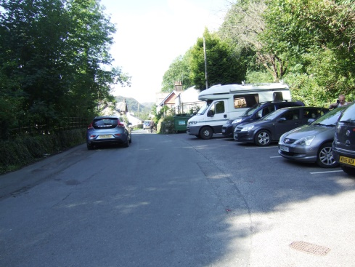 Photo: John Dennis

Location: Eskdale
Grid ref: NY142002

Navigate to Eskdale Green from the A595 from either Holmrook if coming from north and west or via the Duddon Valley (over Birker Fell) if coming from the south.

Walk - Miterdale Meander
______________________________________________________________________

Fell Gate car park - 0.8 km up Walna Scar Road, from Coniston
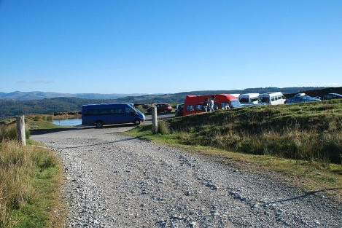 Photo:

Location: Coniston
Grid ref: SD 289 970

Access the village from the north on the A593; just after passing the Black Bull hotel on the right, bear right over the bridge to pass a fuel filling station on the left. In about 50m turn right at a crossroads and follow the road (Walna Scar road) upwards – after an initial steep section continue upwards round several bends to reach a gate. Pass through the gate and onto a rough car park.

Walk - Coniston Old Man and Dow Crag
______________________________________________________________________

Glen Mary Bridge / Tom Gill National Trust car park
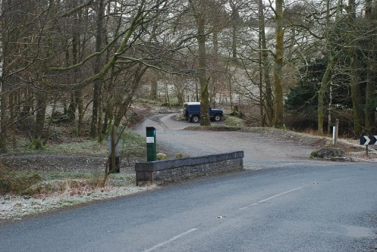 Photo:

Grid ref: SD322999
Location: Near Coniston

The car park is located about 2 miles (3.4km) north east of Coniston on the right hand side of the A593 (Coniston to Ambleside road) just past Yew Tree farm (on left)

Walks – Black Crag and Yewdale, Hills, Gills and Falls
______________________________________________________________________

Tilberthwaite Quarry car park, near Coniston
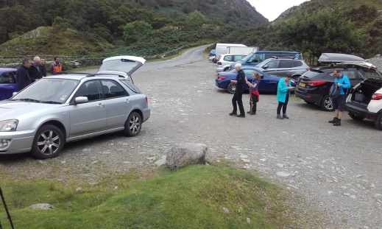 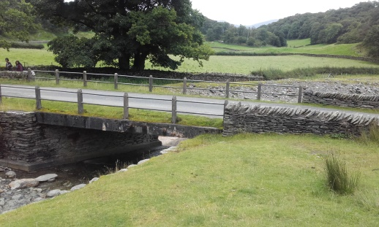 Photo: Sally Jones

Grid ref: NY306010
Location: Near Coniston

From Coniston travel north east for about 1.5 miles (2.5km) along the A593 (Coniston to Ambleside road) then turn left along a single track road signed Tilberthwaite, keeping the beck on your right hand side; continue for a further 1 mile (1.6km) to reach a large car park among quarry workings on the left.

Walks – Caves, Falls and Fells, Family Walk – Cathedral Cave, Little Langdale – Fells and Tarns, Tilberthwaite to Holme Fell
______________________________________________________________________

Torver Parish Room
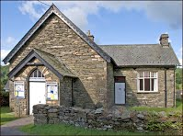 Photo:

Grid ref: SD285943
Location: Near Coniston

The Parish Room is located next to the church in the village of Torver about 2.5 miles (3.9km) south west of Coniston along the A593 (Coniston to Broughton road); there is a small car park adjacent to the Parish Room.

Walk – Blawith Beacon Trek

Ravenglass 'Ratty' Railway Station
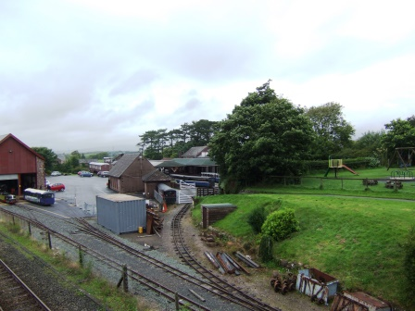 Photo: John Dennis

Location: Ravenglass

The village is reached via a side road off the A595; the turning is well signed and is about 0.8 miles (1.3km) from the main entrance to Muncaster Castle if approaching from the east or about 2.5 miles (3.9km) from Holmrook if approaching from the north. Follow the side road into the village car park, passing under a bridge, taking care not to turn into either the Ravenglass & Eskdale Railway car park or the British Rail station car park. After parking, cross the footbridge at the southern end of the car park to access the station platforms.

Walk – Steam to the Hills
______________________________________________________________________

Ravenglass village car park
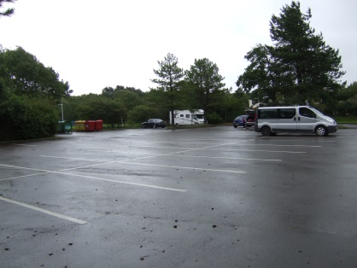 Photo: John Dennis

Location: Ravenglass
Grid ref: SD085965

The village is reached via a side road off the A595; the turning is well signed and is about 0.8 miles (1.3km) from the main entrance to Muncaster Castle if approaching from the east or about 2.5 miles (3.9km) from Holmrook if approaching from the north. Follow the side road into the village car park, passing under a bridge, taking care not to turn into either the Ravenglass & Eskdale Railway car park or the British Rail station car park.

Walk – Esk Estuary Escapade
_____________________________________________________________________

Wasdale Head Green
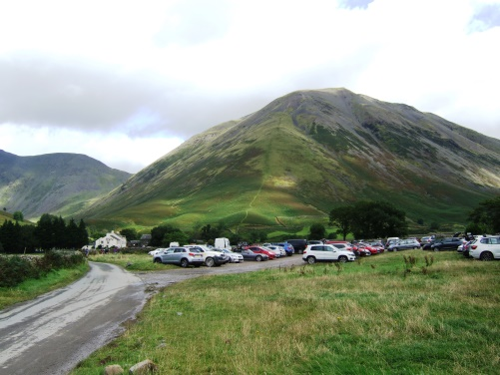 Photo: John Dennis
Location: Wasdale
Grid reference: NY187085

Navigate to Wasdale from the A595 either from Gosforth or Santon Bridge. Follow the valley road, which runs beside the lake for most of its length, for several miles to reach Wasdale Head Green car park.

Walk - Family Wasdale Wander
______________________________________________________________________

North East guided walk start points

Mungrisdale village Hall
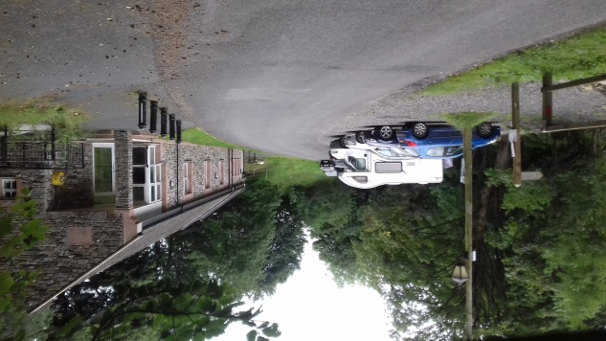 Photo: Graham Wood

From the M6, leave at junction 40, take the A66 towards Keswick. Approx. 9 miles turn right to Mungrisdale village and Caldbeck.

Walks – Blencathra Summit

______________________________________________________________________

Swirls car park
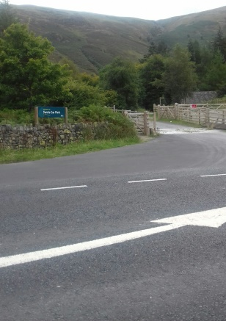 Photo: Graham Wood
______________________________________________________________________
Ullswater Information Centre, Glenridding
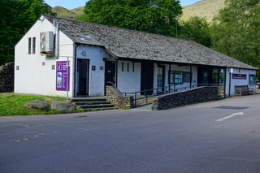 Photo: web
Location: Glenridding, Ullswater
Address: Beckside Car Park, Glenridding
Postcode: CA11 0PD

Walks – Most of the NE walks
North West guided walk start points
Great Wood NT car park
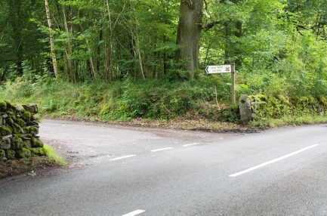 Photo: Barry Grayburn

Walk – Autumn Walk above Derwentwater
______________________________________________________________________
Honister NT car park, behind the youth hostel
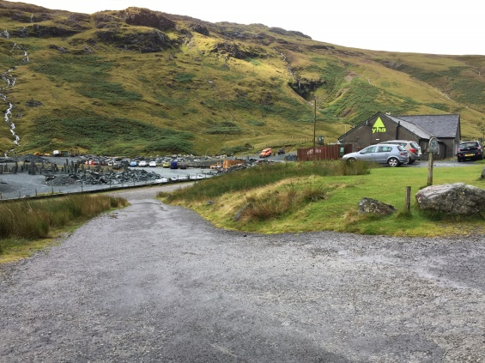 Photo: Roy Ellis

Walks – Haystacks – Wainwright’s Favourite Fell, Glorious Green Gable

Keswick Information Centre (The Moot Hall)
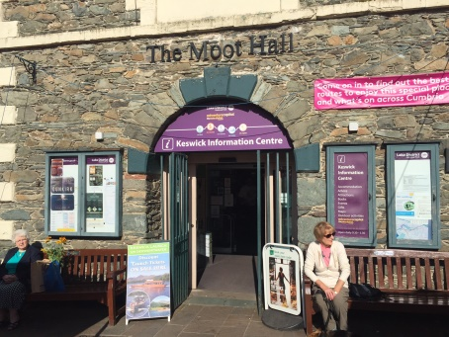 Photo: Roy Ellis

Walks – Discover Keswick

Legburthwaite car park, Thirlmere, off the B5322
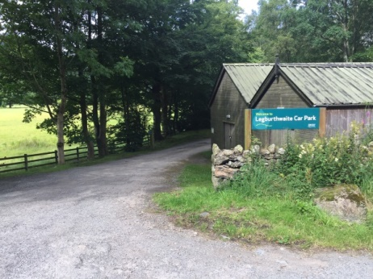 Photo: Roy Ellis

Walks – High Rigg – A Mountain in Miniature

Outside main entrance Theatre by the Lake, Keswick
(Photo pending)

Walks – Mini Trekkers
_____________________________________________________________________

Outside tea room, Dodd Wood car park, near Bassenthwaite
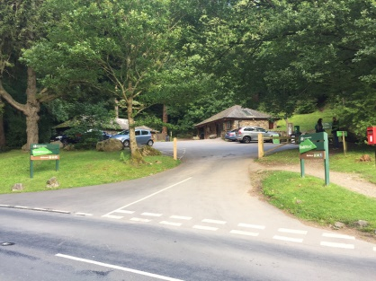 Photo: Roy Ellis

Walks – Ullock Pike under Skiddaw

Rosthwaite NT car park
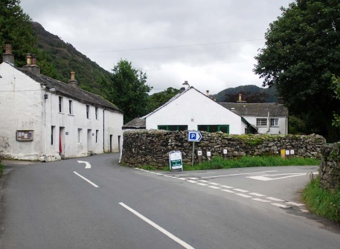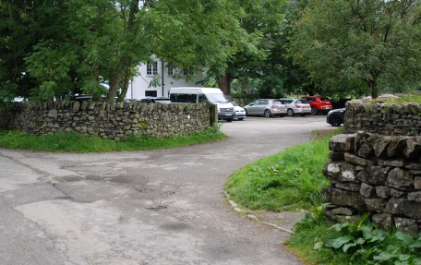 Photos: Barry Grayburn

Walks – High Spy Ridge and Valleys

Seatoller NT car park
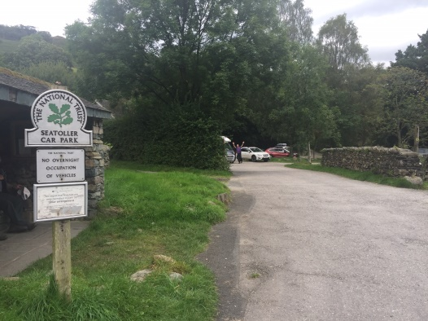 Photo: Roy Ellis

Walks – Castle Crag and Millicans Cave

Seathwaite car park
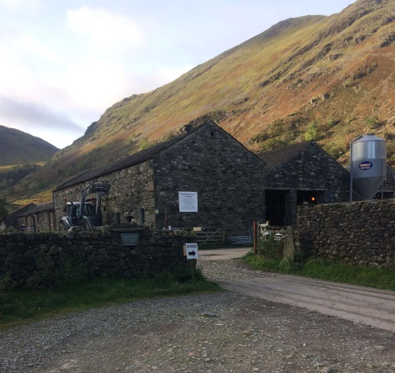 Photo: Barry Grayburn

Walks – Scafell Pike – England’s Highest Peak, Majestic Great Gable
_____________________________________________________________________

The Fish Hotel, Buttermere. Park in LDNP or NT car park
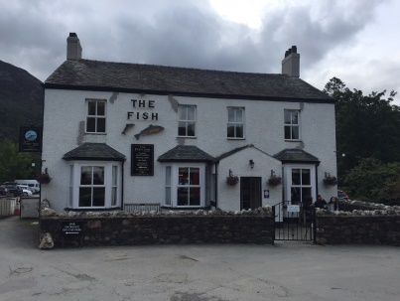 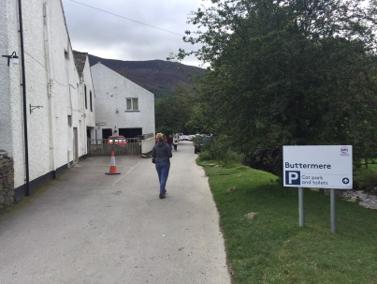 P P Photo Photos: Roy Ellis

Walks – Secret Valley of the Bluebells, Rannerdale Knotts
____________________________________________________________________

South East guided walk start points

To be added soon.

